**Exercise 1: Mocking and Stubbing**

**Code:**

**ExternalApi.java:**

package com.example.MockitoDemo;

public interface ExternalApi {

String getData();

}

**MyService.java**:

package com.example.MockitoDemo;

public class MyService {

private ExternalApi api;

public MyService(ExternalApi api) {

this.api = api;

}

public String fetchData() {

return api.getData();

}

}

**MyServiceTest.java:**

package com.example.MockitoDemo;

import static org.junit.jupiter.api.Assertions.*assertEquals*;

import static org.mockito.Mockito.*;

import org.junit.jupiter.api.Test;

public class MyServiceTest {

*@Test*

public void testExternalApi() {

ExternalApi mockApi = *mock*(ExternalApi.class);

*when*(mockApi.getData()).thenReturn("Mock Data");

MyService service = new MyService(mockApi);

String result = service.fetchData();

*assertEquals*("Mock Data", result);

}}

**Screenshot:**

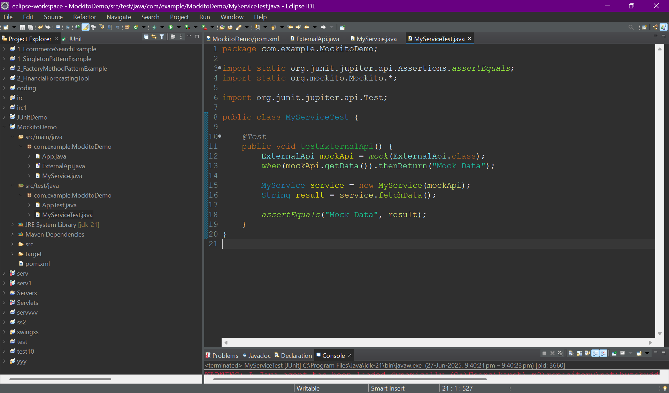

**Output:**

